**Java Programming Lab:**

1. Write a Java program to print the following triangle of numbers (**Done**)

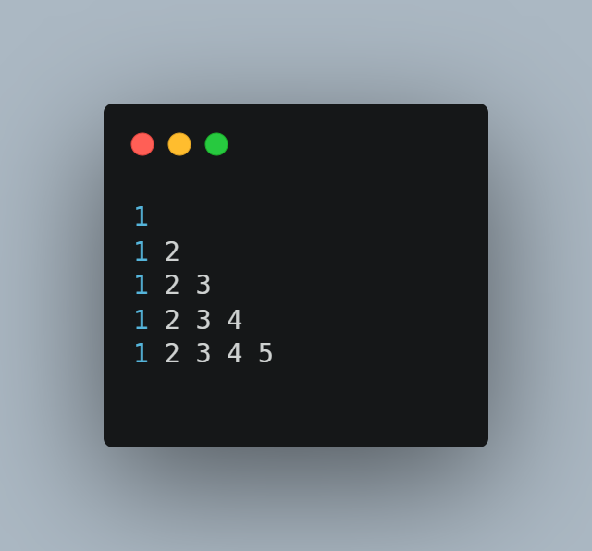

1. Write a Java program to list the factorial of the numbers 1 to 10. To calculate the factorial value use while loop. (Hint Fact of 4=4*3*2*1). **(Done)**
2. Write a Java program**(Done)**
   1. To find the **area** and **circumference** of the circle by accepting the radius from the user
   2. To accept a number and find whether the number is **Prime or not**.
3. Write a Java program to demonstrate a division by zero exception.
4. Write a Java program to implement Inner class and demonstrate its Access protection.
5. Write a Java program to demonstrate **Constructor Overloading** and **Method Overloading (Done)**
6. Write a JAVA program to demonstrate **Inheritance.** Sample Program on Java for the implementation of Multiple inheritance using interfaces to calculate the area of a rectangle and triangle.
7. Write a Java applet program, which handles **keyboard event.**